Teacher:
Name:


YEAR 11 SEMESTER ONE 2008

HUMAN BIOLOGY EXAMINATION

SECTION B

Section A: Multiple Choice – 40 Questions – 40%
Answer the multiple choice questions by CROSSING out the letter of your choice on the answer sheet provided.

Section B: Short Answers – 9 Questions – 40%
Answer the questions in the spaces provided. Answers are to be in BLUE or BLACK biro.

Section C: Extended Answers – 2 Questions – 20%
Answer all parts of question 1 or 2 and all parts of question 3 or 4. Write the answer on the lined paper provided.
SECTION B: - Short Answer
Section A = / 40

Section B = / 110 X 0.364 = /40

Section C = /20

Total /100

You must answer all the questions in Section B in the spaces provided. Answers must be in BLUE or BLACK PEN, diagrams are to be in pencil and clearly labelled.

Question 41

(a) Describe how the following factors affect the rate of diffusion?

Concentration of Molecules
_________________________________________________________________________
_________________________________________________________________________
_________________________________________________________________________
_________________________________________________________________________
Temperature
_________________________________________________________________________
_________________________________________________________________________
_________________________________________________________________________
_________________________________________________________________________
(2)
(b) What are the differences between aerobic and anaerobic respiration?
Aerobic Respiration _________________________________________________________________________
_________________________________________________________________________
_________________________________________________________________________
_________________________________________________________________________

Anaerobic Respiration
_________________________________________________________________________
_________________________________________________________________________
_________________________________________________________________________
_________________________________________________________________________

(c) Identify the organelles labelled from the following diagrams and write a major function for each of them below.

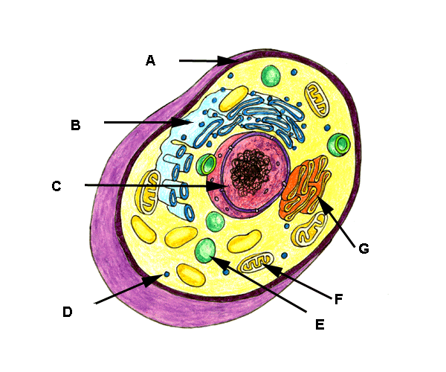

 | STRUCTURE | FUNCTION
A
B
C
F
G

(10)
(d) Complete this equation.

C₆ H₁₂O₆ + ___________________ 6CO₂ + 6H₂0 + _____________
(4)

(e) Which type of respiration is represented by this equation?
_________________________________________________________________________
(1)
(f) In which part of the cell does the equation in (d) take place?

_________________________________________________________________________
(1)
(g) Explain how ATP is formed in the body. Use a diagram to explain you answer.

___________________________________________________________________________
___________________________________________________________________________
___________________________________________________________________________
___________________________________________________________________________
___________________________________________________________________________
___________________________________________________________________________
___________________________________________________________________________
(3)

Question 42.
Refer to the diagram below:
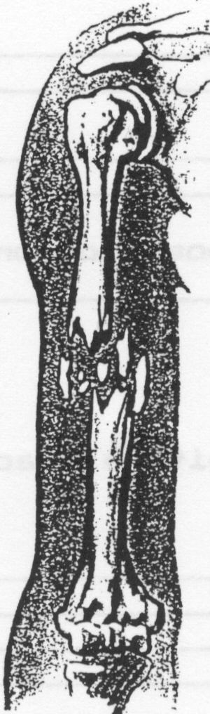

(a) Describe the type of fracture illustrated above. ____________________________
(1)
(b) Describe four main symptoms which may indicate that a fracture has occurred.
(i)_____________________________________________________________________
_______________________________________________________________________ (ii)____________________________________________________________________
______________________________________________________________________
(iii)___________________________________________________________________
______________________________________________________________________
(iv)___________________________________________________________________
______________________________________________________________________

(4)
(c) Why must a fracture be immobilised before moving the casualty?
_____________________________________________________________________________
_____________________________________________________________________________
_____________________________________________________________________________
(2)

Question 43.
FIGURE 1 – Skeleton and skeletal features of a quadruped primate, gorilla and human.
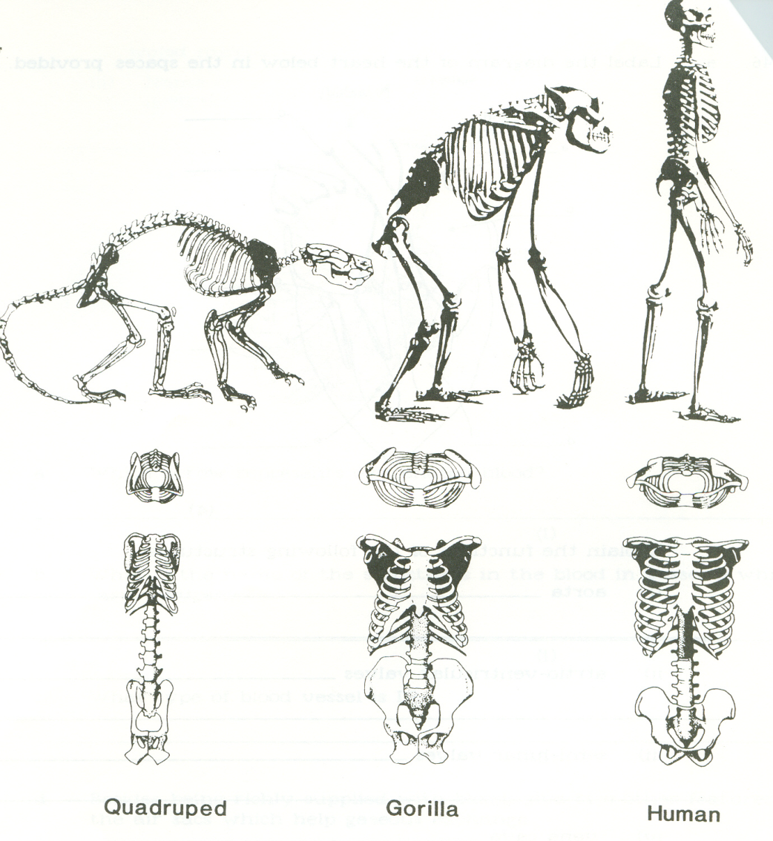
Examine the illustrations of the full skeleton and skeletal features belonging to a quadrupedal primate, gorilla and human in Figure 1 above.

(a) State ONE feature of the quadrupedal skeleton illustrated in Figure 1 which is suited for quadrupedal walking and explain how it assists this mode of locomotion.

_________________________________________________________________________________________________________________________________________________________________________________________________________________________________________________________________________________ (3)

(b) Describe TWO structural features evident in Figure 1 which account for the fact that the gorilla is not able to walk bipedally for extended periods of time.

(i)____________________________________________________________________________________________________________________________________________________________________________________

(ii)___________________________________________________________________________________________________________________________________________________________________________________
(4)

(c) Describe TWO structural features evident in Figure 1 which enable humans to carry out bipedalism.

(i)____________________________________________________________________________________________________________________________________________________________________________________

(ii)___________________________________________________________________________________________________________________________________________________________________________________
(4)

FIGURE 2 – PRIMATE HANDS

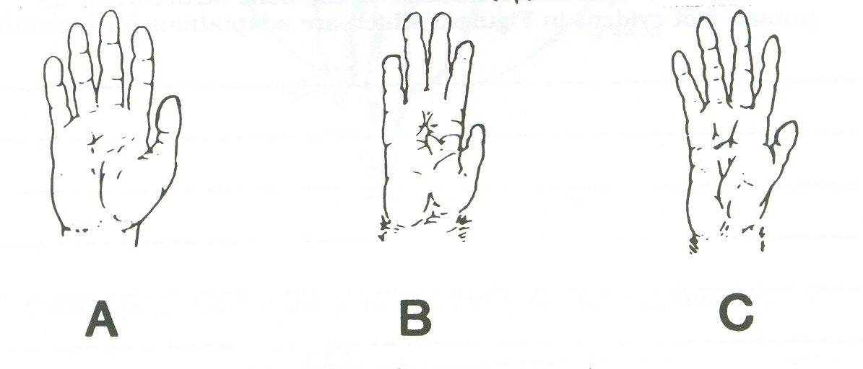

(d) Which of the hands illustrated in Figure 2 is not suited for brachiation? Give three reasons to justify your answer.

- _______________________________________________________________________________________________________________________________________________________________________
- ________________________________________________________________________________________________________________________________________________________________________
- ________________________________________________________________________________________________________________________________________________________________________ (4)

Question 44. Use the following illustrations to answer the questions on the following page.
NB - The arcs on the diagram represent the range of motion for each joint.

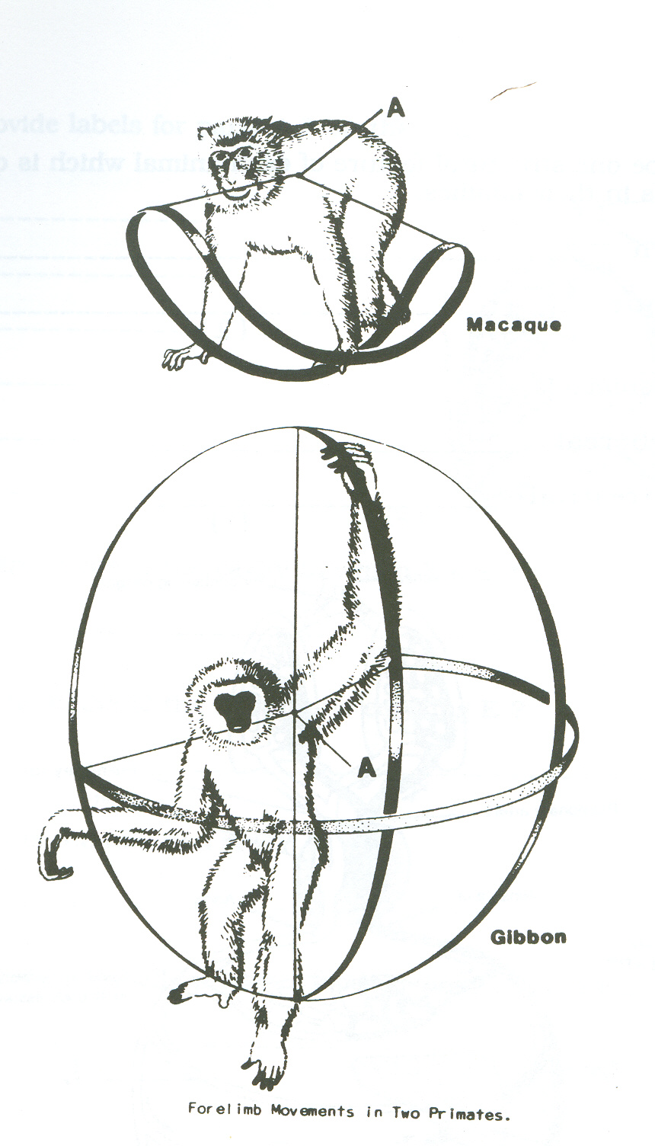

(a) What type of joint is the joint labelled A on the diagram above?

__________________________________________________________________________
(1)
(b) Both of these animals belong to the same sub-order. What is it?

__________________________________________________________________________
(1)

(c) Give the family name for each animal.
Gibbon____________________________________________________________________

Macaque___________________________________________________________________

(2)

- Explain with reference to structure, why a gibbon can brachiate whereas a macaque uses quadrupedal locomotion?

_________________________________________________________________________________
_________________________________________________________________________________
_________________________________________________________________________________
_________________________________________________________________________________
_________________________________________________________________________________
_________________________________________________________________________________
_________________________________________________________________________________
(4)

Question 45.

SUBSTANCE | NORMAL CELL CONTENTS (mg/mL) | SOLUTION 1  (mg/mL) | SOLUTION 2  (mg/mL)
Sodium Ions | 70.0 | 30.0 | 100.0
Magnesium Ions | 0.003 | 0.005 | 0.001
Potassium Ions | 420.0 | 400.0 | 500.0
Calcium Ions | 1.2 | 0.6 | 10.0
Chlorine Ions | 510.0 | 600.0 | 100.0
Total | 1001.203 | 1030.205 | 710.001

(a) If the cell was placed in solution 1, describe the nett movement of water and explain why this would occur?
________________________________________________________________________________
________________________________________________________________________________
________________________________________________________________________________
(3)
(b) If the cell was placed in solution 2, describe the nett movement of Sodium and explain why this would occur?
________________________________________________________________________________
________________________________________________________________________________
________________________________________________________________________________
(3)

(c) When the cell was placed in solution 2, its chlorine level remained constant at 510.0mg/mL. Assuming that the cell membrane was permeable to chlorine, describe in detail how the cell achieved this.
________________________________________________________________________________
________________________________________________________________________________
________________________________________________________________________________
(3)

Question 46.

- Name the following tissue types and a specific location in the body where you would find each tissue. Use the table on the following page.

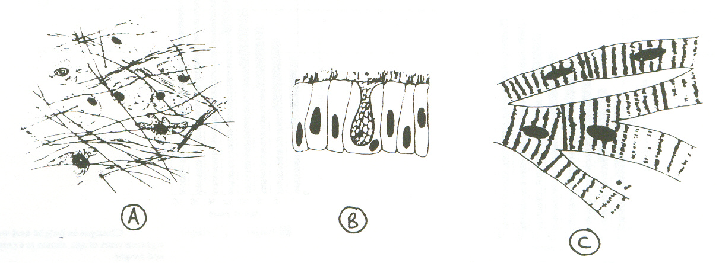
C
B
A

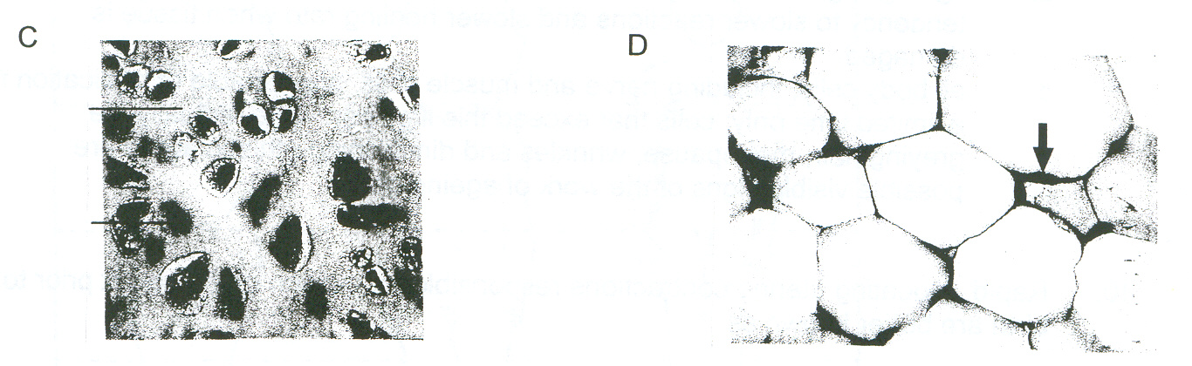
E
D

TISSUE | NAME SPECIFIC TISSUE | LOCATION FOUND IN BODY
A
B
C
D
E

(10)
(b) Complete the following:
(i) What is a ‘carcinogen’? Give two examples to support your answer.

_____________________________________________________________________________
_____________________________________________________________________________
_____________________________________________________________________________
(ii) Explain how carcinogens can cause cancer. (3)

_____________________________________________________________________________
_____________________________________________________________________________
(2)

- Describe some positive steps that you can take to reduce the risk of cancer later in life.
_______________________________________________________________________________
_______________________________________________________________________________
_______________________________________________________________________________
_______________________________________________________________________________
_______________________________________________________________________________
_______________________________________________________________________________
(3)

Question 47.

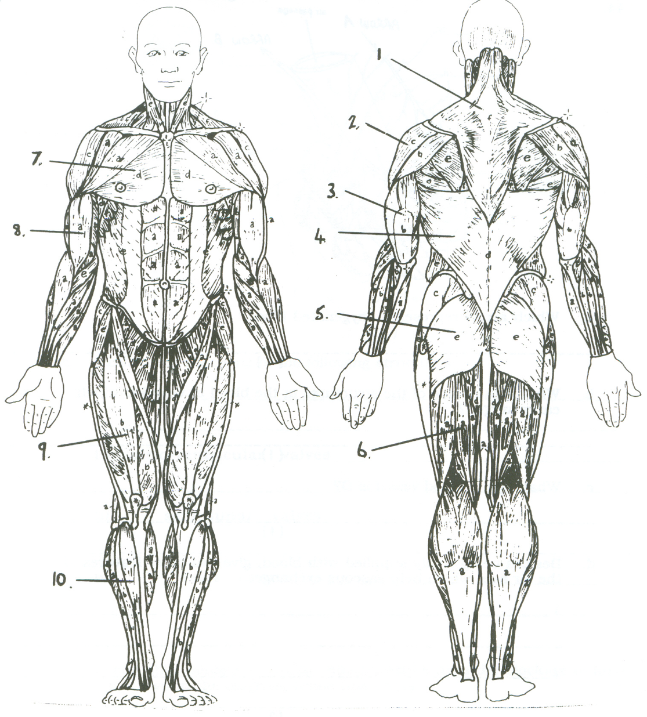

Label the following muscles from the diagram above.

Number | Muscle Name
2
5
6
9
10

(5)
Question 48. The diagram below shows the main muscle groups associated with the upper limb.

(a)
(i) Which muscle groups would raise the humerus as shown by the arrow?
____________________________________________________________________
____________________________________________________________________
(ii) Which joint would be involved in this movement?
____________________________________________________________________
(iii) What type of joint is this?
____________________________________________________________________
(iv) Why do we have such great flexibility at this joint?
____________________________________________________________________
____________________________________________________________________

(4)
(b) The biceps muscle has two heads. Describe where the origins are.
_______________________________________________________________________________
_______________________________________________________________________________
_______________________________________________________________________________
(2)

(c) Complete the following table by drawing the joint and providing one example of where it is found in the body.

TYPE | DIAGRAM | EXAMPLE
GLIDING JOINT
SADDLE JOINT

(6)
(d) Describe how the knee is structure to cope with the range of movements and stresses required of it. Use a diagram to support your answer.
_______________________________________________________________________________
_______________________________________________________________________________
_______________________________________________________________________________
_______________________________________________________________________________
_______________________________________________________________________________
_______________________________________________________________________________
_______________________________________________________________________________
_______________________________________________________________________________
_______________________________________________________________________________
_______________________________________________________________________________
_______________________________________________________________________________
_______________________________________________________________________________
_______________________________________________________________________________
(4)

Question 49.

Draw the following diagrams to show their respective phases of Mitosis and give an explanation for each.
(9)
INTERPHASE

____________________________________________________________________________________________________________________________________________________________________________________________________________

METAPHASE
____________________________________________________________________________________________________________________________________________________________________________________________________________

TELOPHASE
____________________________________________________________________________________________________________________________________________________________________________________________________________

